Family Astronomy Night
Hosted by Lou Mayo, Planetary Scientist, and Dorian Janney, Science Educator
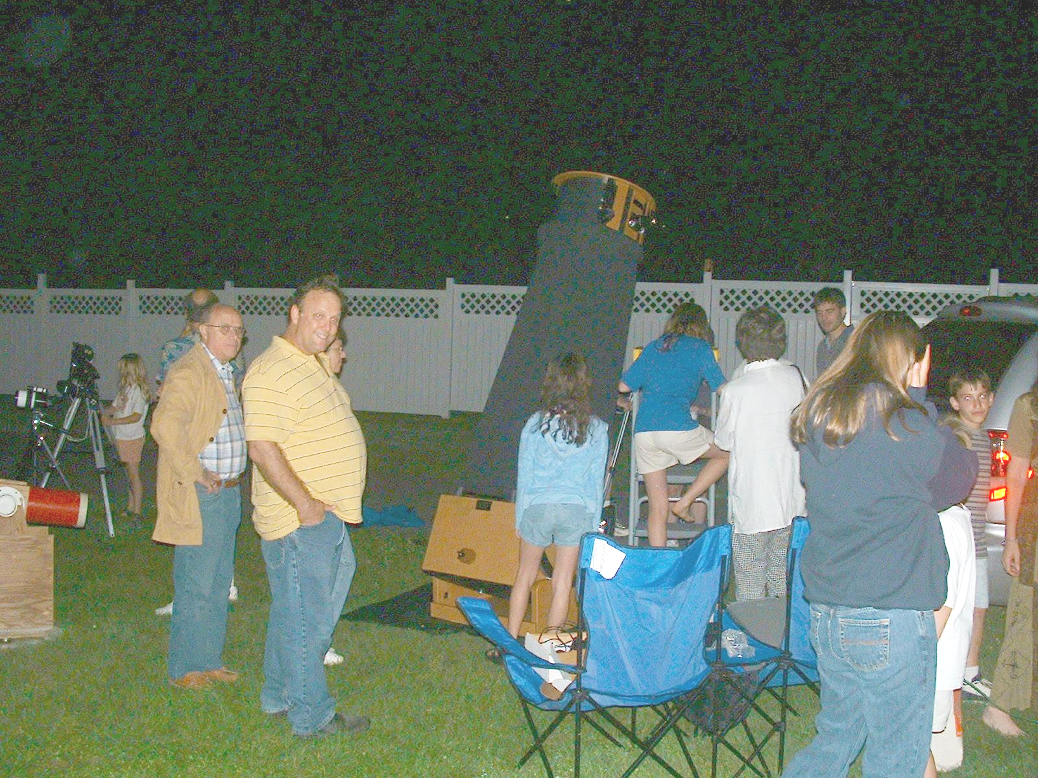

Saturday, March 27 from 7 PM until whenever… We will explore Saturn tonight, and well as other planets and deep sky objects.

At the home of Dorian Janney
9617 Harvest Knolls Way, Damascus, MD
301-414-0121

This is an informal "get-together" for all people who have an interest in astronomy.

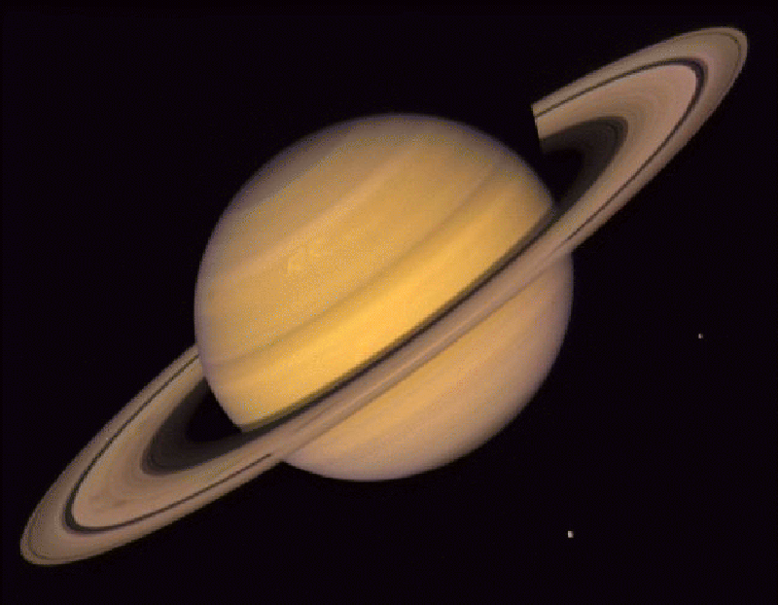
We will have an astronomer or two on hand to find various celestial objects- planets, stars, galaxies, nebulas, and the like- with their telescopes. We’ll also have books, videos, games, computer software, and other things that are related to astronomy inside the house. If the weather isn't conducive to stargazing, we will still have an astronomy gathering. Lou Mayo, an astronomer from Goddard Space Flight Center, will do a slide show presentation on “The Cassini Mission to Saturn”. Dorian Janney, a NASA/JPL Solar System Educator will present an educational activity related to Saturn and its exploration.

If you have a telescope and would like to set it up, please bring it! The more telescopes, the better! Children are invited and encouraged! We’ll have the Cassini presentation from Lou around 7:30, and we’ll be out observing from 8:30 on…

Please feel free to pass on the word- the more the merrier!

No RSVP required- just come if you can...

DIRECTIONS It would be best if you park at Woodfield Elem. School as the house is only a short one-minute walk from there. We will set up telescopes in the driveway, and the lights from the cars really interfere with the viewing. If you should park on Harvest Knolls Way, please be sure to park on the road and not on the grass, as the neighbors would be appreciative...

From I-270

- Take the Father Hurley Blvd. exit, going east toward Damascus
- Take 27 to Sweepstakes (first light after passing the "Welcome to Damascus" sign)
- Turn right onto Sweepstakes, and take this for one mile until it ends at Rt.124.
- Turn right onto Rt. 124 (aka Woodfield Rd)
- Take 124 for about 0.5 miles, turning right to park at Woodfield Elem.
- Cross 124, and the house is the fourth driveway on the left 9617 Harvest Knolls Way

